移动应用开发 第二次作业

Vision OS AboutMe App

github链接：<https://github.com/QIUPH8023/AppleDevelopment>

遵循MVVM的架构，考虑About Me页面的增加，对M、V、VM来说各自需要增加什么？

**Model：**模型部分负责存储和管理应用数据。在项目中，通过创建一个struct来表示个人介绍信息。

e.g.

let name: String = "QIU Penghao"

let introduction: String = "I am a ..."

let imageUrl: String = "AboutMePicture.jpg"

**View：**视图部分需要创建一个AboutMe的SwiftUI 视图来展示页面。包括eyebrow, heading, abstract, overview, callToAction等内容。

e.g.

case .aboutme:

String(localized: "About The Author", comment: "The subtitile of the About Me module.")

case .aboutme:

String(localized: "About Me", comment: "Thr title of a module in the app.")

**ViewModel：**视图模型负责提供数据给视图，并处理与模型的交互。需要创建一个视图模型来处理 "About Me" 页面所需的数据和逻辑。

e.g.

// **MARK: - About Me**

    var isShowingAboutMe: Bool = false

    var aboutMeName: String = "QIU Penghao"

    var aboutMeIntroduction: String = "This is My introduction."

world运行截图

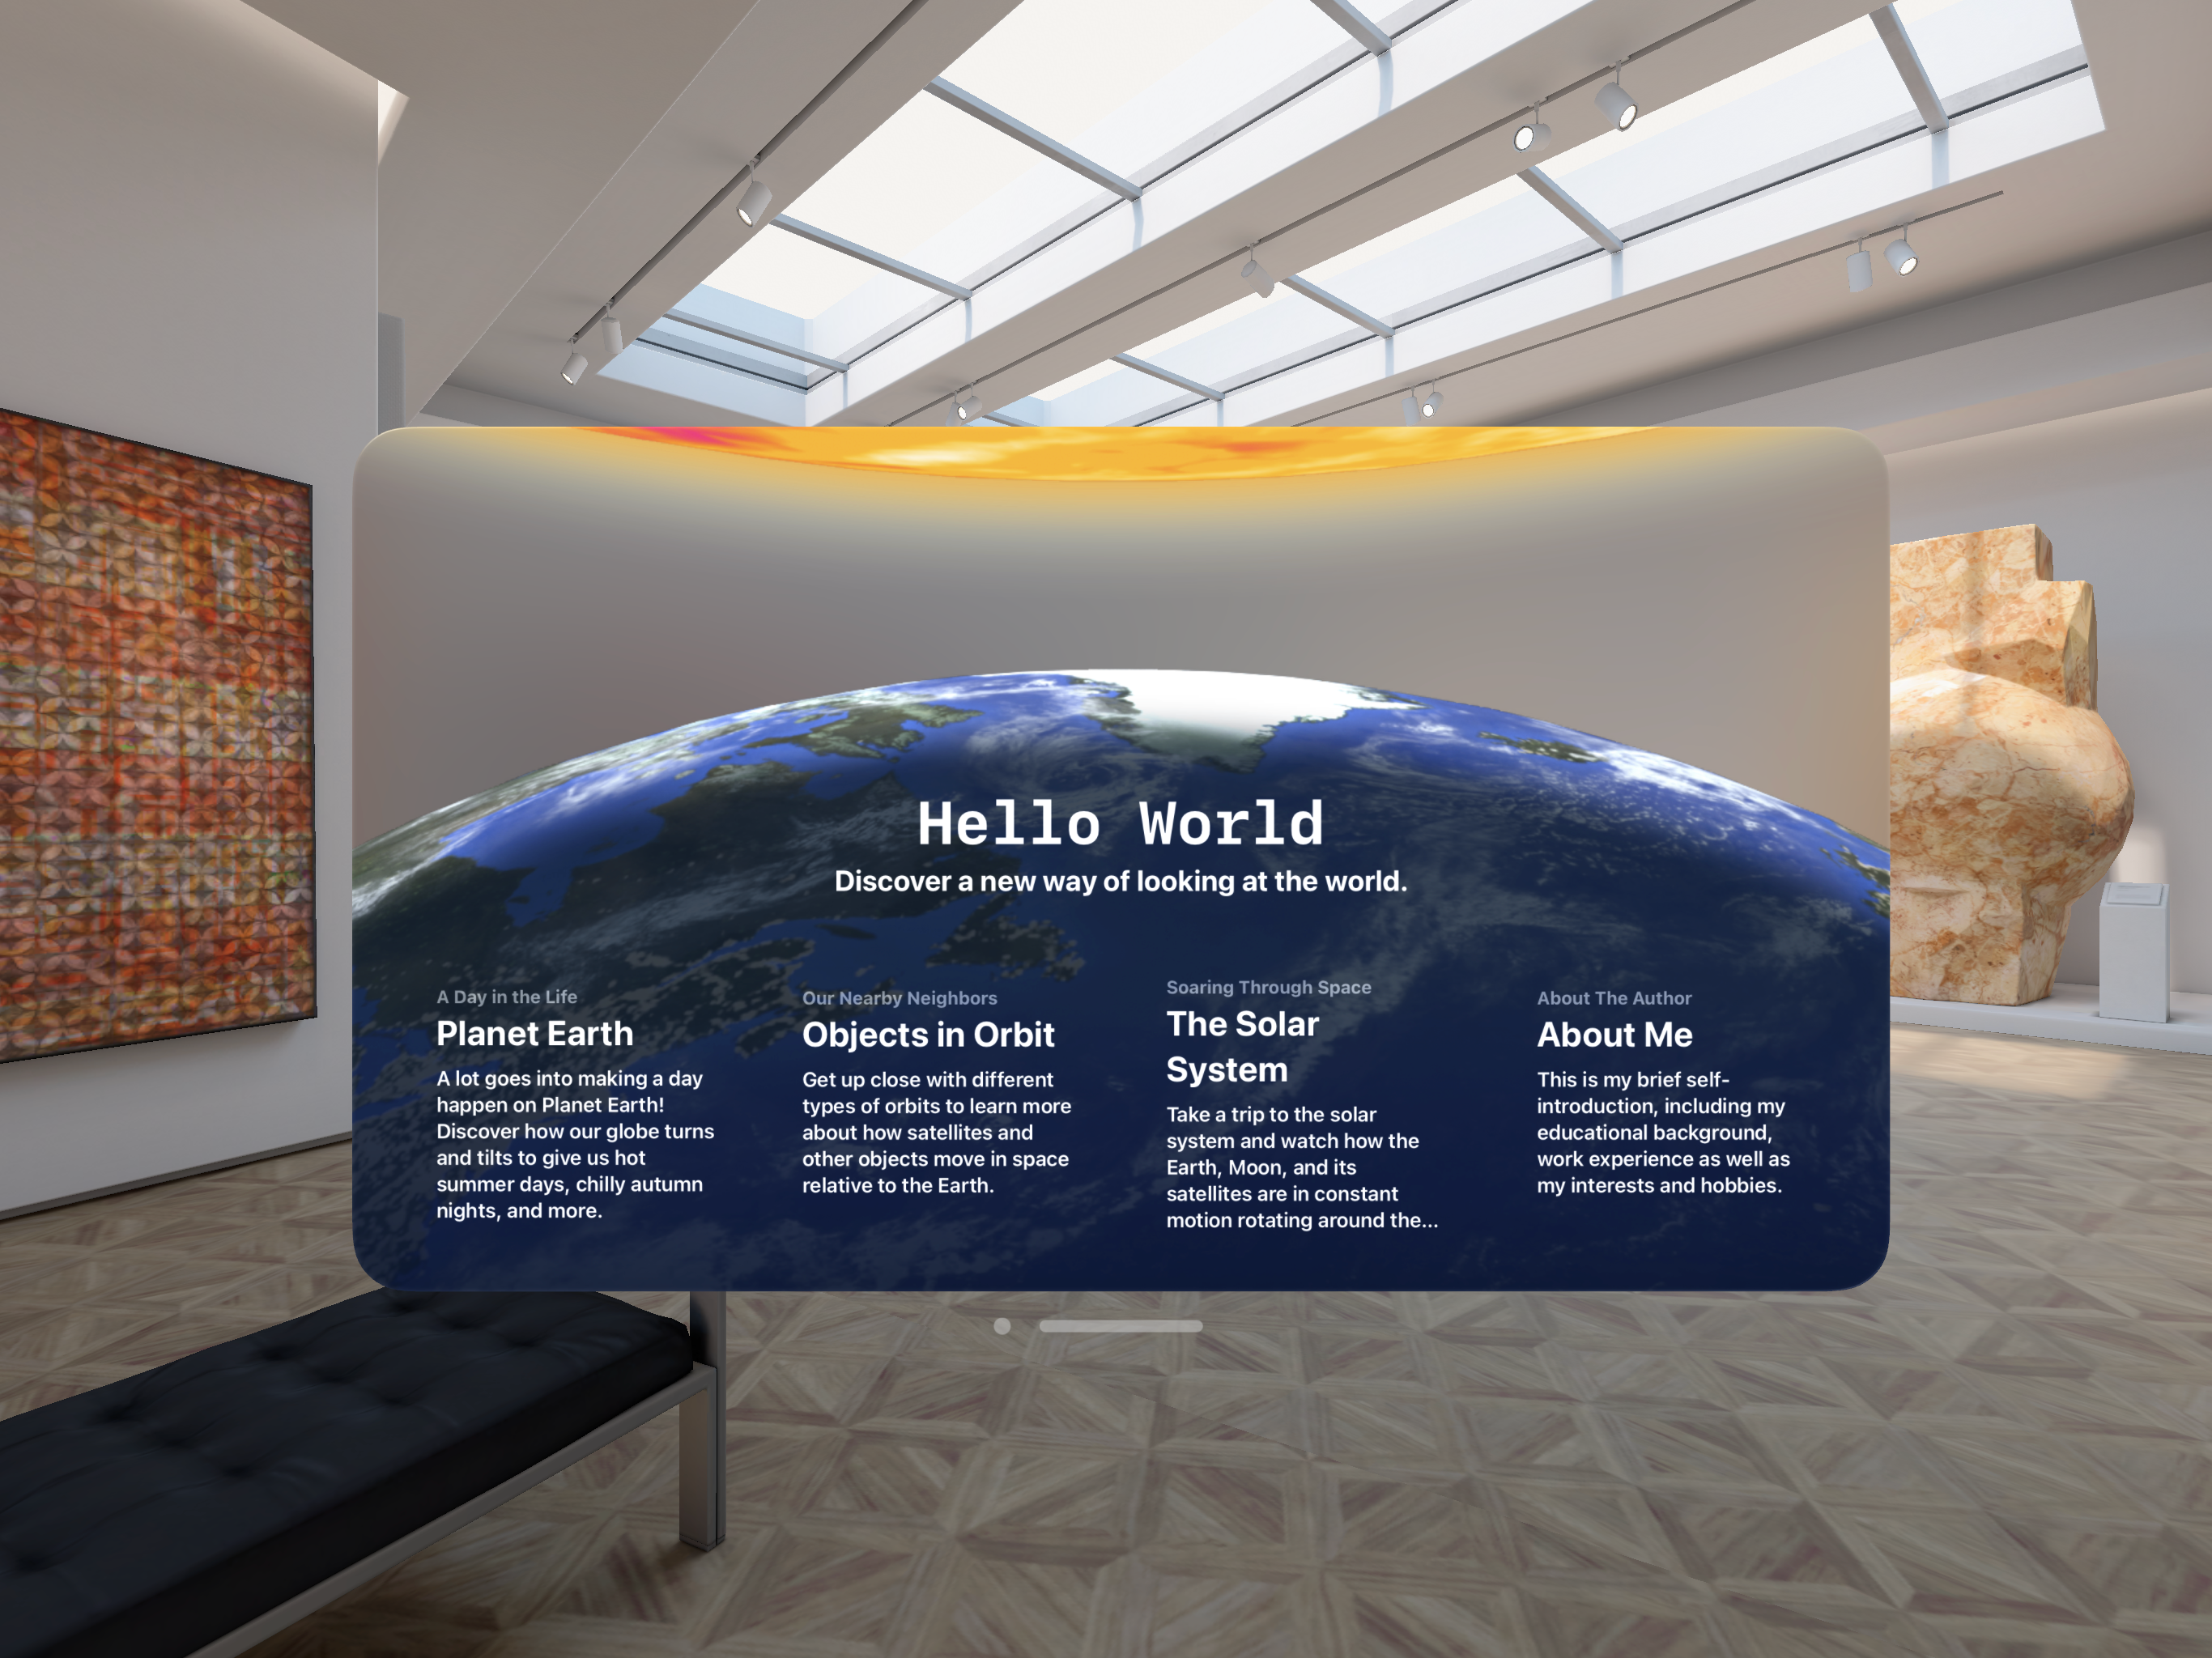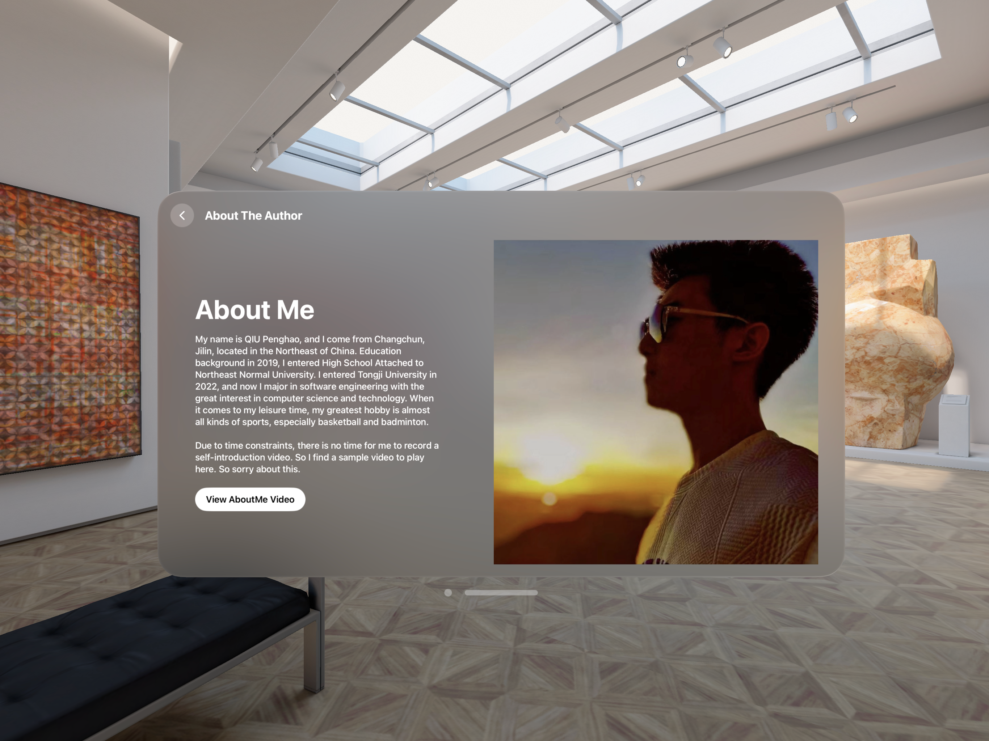

VisionOS World

|  |  |  |
| --- | --- | --- |
| Folder | File | Abstract |
| Modules | Modules | The top level navigation stack for the app. |
| TableOfContents | The launching point for the app's modules. |
| ModuleCard | A card that displays a navigation destination. |
| Module Detail | A detail view that presents information about different module types. |
| Globe | Globe | The globe content for a volume. |
| GlobeControls | Controls that people can use to manipulate the globe in a volume. |
| GlobeModule | The module detail content that's specific to the globe module. |
| GlobeToggle | A toggle that activates or deactivates the globe volume. |
| Orbit | Orbit | The model content for the orbit module. |
| OrbirModule | The module detail content that's specific to the orbit module. |
| OrbitToggle | A toggle that activates or deactivates the orbit scene. |
| Solar System | SolarSystem | The model content for the solar system module. |
| SolarSystemControls | The control panel to display along with the solar system view. |
| SolarSystemModule | The module detail content that's specific to the solar system module. |
| SolarSystemToggle | A toggle that activates or deactivates the solar system scene. |
| Reality Views | Earth | The model of the Earth. |
| Sun | The model of the sun. |
| Starfield | A large sphere that has an image of the night sky on its inner surface. |
| Entities | EarthEntity | An entity that represents the Earth and all its moving parts. |
| EE+Configuration | Configuration information for Earth entities. |
| SatelliteEntity | A satellite entity. |
| SE+Configuration | Configuration information for satellite entities. |
| Entity+Sunlight | Sunlight supplied through an image-based light. |
| Entity+Trace | Convenience methods for drawing a trace behind a satellite. |
| Systems | RotationSystem | A system and component for creating entity rotation. |
| TraceSystem | A system and component for drawing traces behind satellites. |
| Modifiers | PlacementGesture | A modifier for placing objects. |
| DragRotationModifier | A modifier for turning drag gestures into rotation. |
| TypeTextModifier | A modifier for typing text into a text view. |
| Model | ViewModel | The stored data for the app. |
| Module | The modules that the app can present. |
| Settings | SettingButton | A modifier for adding a developer settings button. |
| GlobeSettings | Debug setting controls for the globe module. |
| OrbitSettings | Debug setting controls for the orbit module. |
| SolarSystemSettings | Debug setting controls for the solar system module. |
| EarthSettings | Settings for the Earth entity. |
| SatellitesSettings | Settings for the satellite entities. |
| SliderGrifRow | A supporting view for controlling developer settings. |